APPLICANT

PROJECT COORDINATOR
Name: | The coordinator is the person with whom the Fund will communicate throughout the  project.
E-mail address: | The main contact e-mail for the project (it can be identical to the registration e-mail associated with this application form).
Telephone: | Please enter the number in international format (incl. the country code, e.g. +420, +36,  +48, +421...).

  - ORGANIZATION DETAILS:

Organization name (original): | The organization’s official name.
Organization name (English): | Official English translation, where available.
Statutory representative: | The full name of the representative legally responsible for the organization (e.g. director,  chairman)
ID No. of organization: | Registration number or tax ID in the registry of the respective country
Registered VAT Payer: | If your organization is a registered VAT payer, choose YES.
Organization legal form: | Enter the legal form of your organization (e.g., civic association, foundation, university, Ltd./LLC, etc.).

  - REGISTERED SEAT/ADDRESS:

Street, house no.:
City:
Postal code:
Country:

MAILING/POSTAL ADDRESS – FILL OUT IF IT DIFFERS FROM THE ADDRESS STATED IN THE PREVIOUS POINT.

Street, house no.:
City:
Postal code:
Country:

  - CONTACT DETAILS

Telephone no.: | Please enter the number in international format (incl. the country code).
Website: | Please make sure that you enter the valid URL address of your organization’s website.
Social media account: | Please enter the link or name for your Facebook/Instagram account (if any).

PARTNERS

PARTNER NO. 1.
Organization name (original): | The full official name of the organization in the native language in Latin letters.
Organization name (English): | Official English translation, where available.
Organization unit (faculty, department, etc.): | Specify the organizational unit (faculty, department, institute, etc.)—where applicable.
Organization unit (English): | Please specify the name of the unit in English (faculty, department, etc.) - if any.
Statutory representative: | The full name of the representative legally  responsible for the organization (e.g. director, chairman)
ID No. of organization: | Registration number or tax ID in the registry of the respective country
Registered VAT Payer: | If your organization is a registered VAT payer, choose YES.
Organization type: | Enter the legal form of the organization (e.g., civic association, foundation, university, Ltd./LLC, etc.).
Street, house no.:
City:
Postal code:
Country:
E-mail: | Insert your project partner's valid e-mail address.
Telephone no.: | Please enter the number in international format (incl. the country code).
Website: | Please make sure that you enter the valid URL address of your organization’s website.
Justification of involvement:
Describe why you selected this project partner and what qualifies them for the project? Have you cooperated in the past? If yes, in what projects were you involved?

PARTNER NO. 2.
Organization name (original): | The full official name of the organization in the native language in Latin letters.
Organization name (English): | Official English translation, where available.
Organization unit (faculty, department, etc.): | Specify the organizational unit (faculty, department, institute, etc.)—where applicable.
Organization unit (English): | Please specify the name of the unit in English (faculty, department, etc.) - if any.
Statutory representative: | The full name of the representative legally responsible for the organization (e.g. director, chairman)
ID No. of organization: | Registration number or tax ID in the registry of the respective country
Registered VAT Payer: | If your organization is a registered VAT payer, choose YES.
Organization type: | Enter the legal form of the organization (e.g., civic association, foundation, university, Ltd./LLC, etc.).
Street, house no.:
City:
Postal code:
Country:
E-mail: | Insert your project partner's valid e-mail address.
Telephone no.: | Please enter the number in international format (incl. the country code).
Website: | Please make sure that you enter the valid URL  address of your organization’s website.
Justification of involvement:
Describe why you selected this project partner and what qualifies them for the project? Have you cooperated in the past? If yes, in what projects were you involved?
PARTNER NO. 3.
Organization name (original): | The full official name of the organization in the native language in Latin letters.
Organization name (English): | Official English translation, where available.
Organization unit (faculty, department, etc.): | Specify the organizational unit (faculty, department, institute, etc.)—where applicable.
Organization unit (English): | Please specify the name of the unit in English (faculty, department, etc.) - if any.
Statutory representative: | The full name of the representative legally responsible for the organization (e.g. director, chairman)
ID No. of organization: | Registration number or tax ID in the registry of the respective country
Registered VAT Payer: | If your organization is a registered VAT payer, choose YES.
Organization type: | Enter the legal form of the organization (e.g., civic association, foundation, university, Ltd./LLC, etc.).
Street, house no.:
City:
Postal code:
Country:
E-mail: | Insert your project partner's valid e-mail address.
Telephone no.: | Please enter the number in international format (incl. the country code).
Website: | Please make sure that you enter the valid URL address of your organization’s website.
Justification of involvement:
Describe why you selected this project partner and what qualifies them for the project? Have you cooperated in the past? If yes, in what projects were you involved?

- PR OJE CT

PROJECT SUMMARY
    - Project Title:
Use a title that best describes the principle aim of the project. If the grant is to cover only a part of a larger project, reflect it in the title. (max. 100 characters)
    - Implementation Period (from; until):
Specify the entire period during which the project is implemented, i.e., the time when project activities take place and deliverables are produced (and when you can claim cost reimbursement from the grant). NOTE: The implementation period cannot start before the signature of the grant contract. For Visegrad and Visegrad+ Grants, the maximum period for the project implementation is 18 months, while for Strategic Grants, this period can be min. 12, max. 36 months.

    - Short description of the project: Describe the project idea in a 2–3 sentences (Who? What? Where?, How?). (max. 400 characters)
    - Choose the main focus area of your project (choose only the one that best describes your proposal):
      - Culture and Common Identity
      - Education and Capacity Building
      - Innovation, R&D, Entrepreneurship
      - Democratic Values and the Media
      - Public Policy, Legislation and Justice
      - Regional Development, Environment and Tourism
      - Social Development
8-10. (Strategic Priorities set by the V4 presidency on an annual basis – can be found on our website)

    - Choose the main objective of the project:
Identify the main objective that best describes your proposal and its main aims.
You will be able to choose one main objective corresponding to the previously chosen focus area.
For the full list of objectives, please check our website.

PROJECT RELEVANCE AND CONTEXT
    - What is the main issue that your project would like to focus on? What is the current situation that you wish to change?
Please explain the context of your project proposal (the problem you wish to solve, the issue you would like to address). Base your description on available statistics and facts and describe the current state of art. (max. 1600 characters)

    - What should be done to address this issue/problem? How does your project contribute to the solution?
Describe what you believe should be done to bring a positive change in the local community or society in general. How do you and you partners plan to contribute to the change? (max. 1600 characters)

    - What added value does your project bring to the already existing practices? What is the innovative element in your proposal?
What makes this proposal stand out from similar initiatives? What do you offer that has not been done before? (max. 1600 characters)

    - What is the regional relevance of your proposal?
How will the V4 region and/or the region of implementation of the project its citizens benefit from the project? Why is it necessary to address the issue on a regional (Central European) level? (max. 1600 characters)

    - How would you describe your organization’s experience in dealing with the proposed topic? Have you previously implemented similar projects?
Describe your organization's past experience, achievements and track record in the given area to justify your involvement. Please include non-IVF supported projects as well. (max. 1600 characters)

TARGET GROUPS
What target groups do you plan to involve and address in your project? Who will be benefiting from the project directly and indirectly?

Target group | Method of selection | No. of people
What individuals, stakeholders, social groups and/or organizations do you plan to  directly reach? | How do you plan to select this group? | What is the estimated number of people? How many of them will be involved from V4 countries?

SPECIFIC RESULTS
What specific results do you expect to achieve at the end of your project? How do these results contribute to the solution described in section 2.2?

Specific result | Contribution to the project's overall goal
List the specific goals you wish to achieve by the end of your project (e.g. new audiences reached, articles published, people trained). | How do these products/achievements bring you closer to the bigger solution?

DISSEMINATION AND FOLLOW-UP
    - What activities will you carry out to share the results of the project outside your organization and partners?
(max. 1600 characters)

3.7.2. Do you plan any activities in the future which will build on the results of this project?
(max. 1600 characters)

OUTPUTS

Project deliverables (or outputs) are concrete products or events that help you achieve your goals. List all deliverables—events (workshops, presentations, opening events…) or products (exhibitions, publications…)—planned within the project to contribute to the project objectives and add details and associate costs (requested by this grant) with each deliverable. Project overhead costs (running costs) should be summed for the entire project below and are limited by 15% of the requested budget. Other incomes can be listed in the bottom table titled OTHER INCOMES.
Please note that the maximum number of outputs that can be created within a project is 10!

1. Output no. 1. (Product)
01/03/2024-02/04/2024
Describe the output in a detailed way. What is the content, how will it be realized, how does it fit into the bigger project idea?
Target Groups: |  | Describe those individuals, groups and organizations that will be directly involved and/or affected by this output. Indicate the  expected number of the targets and their country of origin.
Role of the Applicant and Partners: |  | Describe the exact role of the Applicant in the preparation/implementation/dissemination of this output.
Describe the exact role of each partner that is taking part in the
preparation/implementation/dissemination of this output.
Dissemination/promotion: |  | Describe how the given project event or the results of the  deliverable will be promoted and spread and how the results will be applied in the partner countries or in the wider region.
BUDGET
Budget category | Budget subcategory |  | Budget description | Sum
Expert fees | In-person services |  | Costs for developing learning course | 500,00
Accommodation and board | Accommodation |  | Hotel room for 2 people | 400,00
TOTAL:  Please note that an event cannot last longer than 10 days. Longer events should be categorized as products. |  |  |  | 900,00
Choose the type of event (in case the selected output is an event).

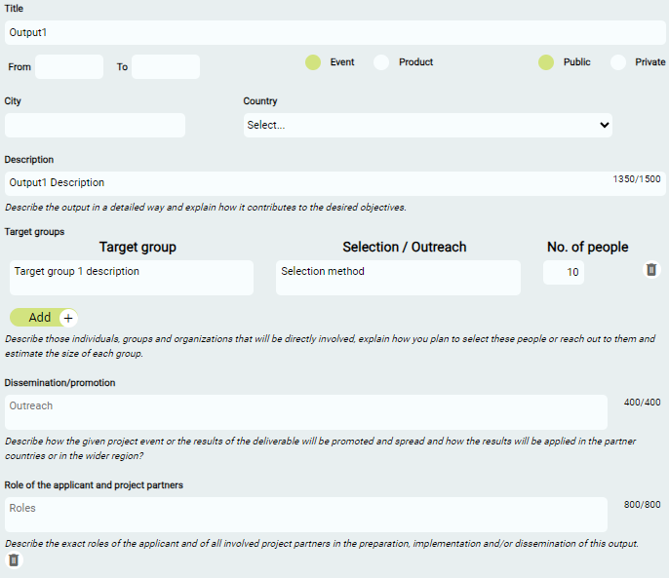
Choose the type of output.

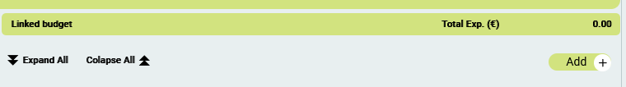
You can add several budget lines to each output using this button:

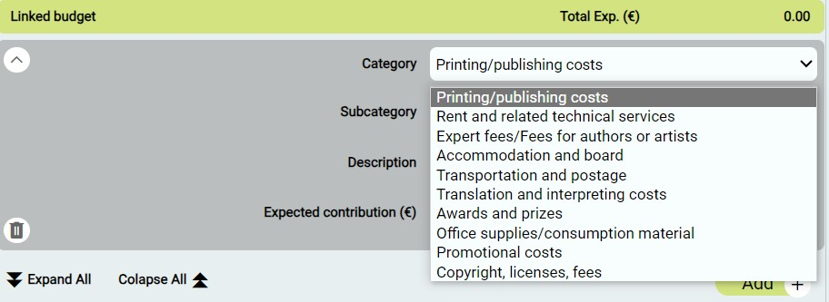
Choose the budget category from the dropdown list.

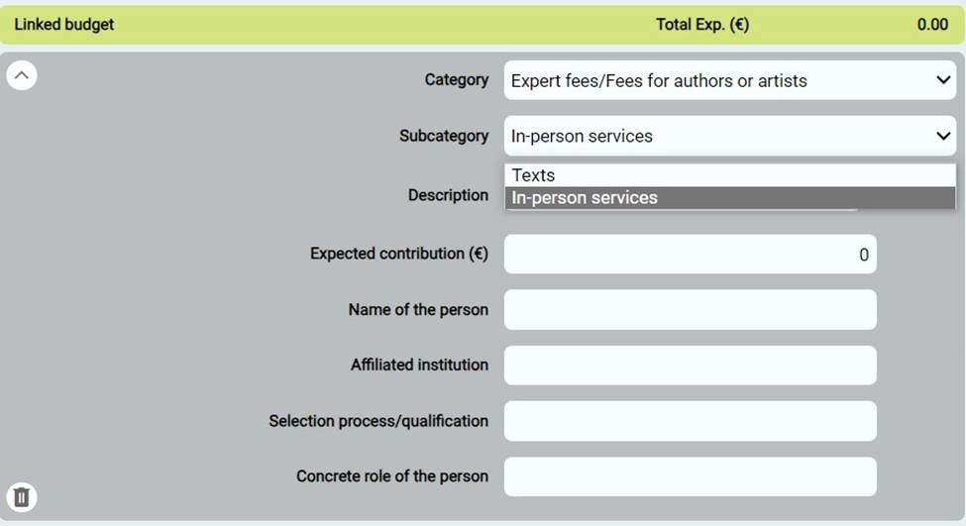
In case of Expert fees fill out all requested information.
Sending institution/employer.
Choose the budget subcategory from the dropdown list.

2. Output no. 2. (Event)
01/03/2024-10/03/2024
Describe the output in a detailed way. What is the content, how will it be realized, how does it fit into the bigger project idea?
Direct Target Groups: | Describe those individuals, groups and organizations that will be

 |  | directly involved and/or affected by this output. Indicate the expected number of the targets and their country of origin.
Role of the Applicant and Partners: |  | Describe the exact role of the Applicant in the  preparation/implementation/dissemination of this output.
 |  | Describe the exact role of each partner that is taking part in the preparation/implementation/dissemination of this output.
Outreach: |  | Describe how the results will be spread and applied in the partner  countries or in the wider region, and how it will help realize the project’s objectives. How do you wish to inform the public?
BUDGET
Budget category | Budget subcategory |  | Budget description | Sum
Expert fees | Texts |  | Costs of editing | 500,00
Accommodation and board | Board and catering |  | Dinner for 3 people | 100,00
TOTAL: |  |  |  | 600,00

ADDITIONAL COSTS

Project overhead costs (Please list all planned project overhead costs (project coordination, accounting, etc.) and describe in detail what they entail).
(Please list all planned project overhead costs (project coordination, accounting, etc.) and describe in detail what they entail).

Project audit costs (Expert fee).
Please calculate the costs for project audit (obligatory for budgets above €15,000).

OTHER INCOMES

Other financial or non-financial (in-kind) contributions to the project budget

Contribution type | Description | Sum in (€)
List all confirmed or expected financial or non-financial contributions to the project budget other than this grant and specify each income.
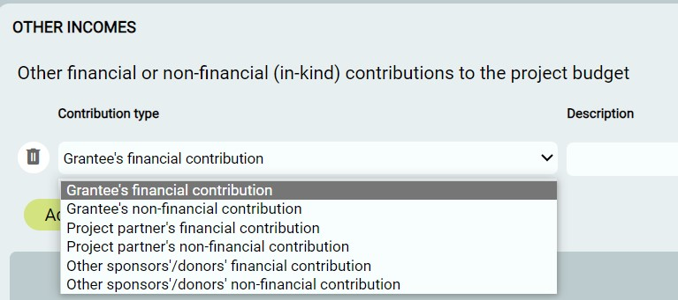
Select the type of other income from the dropdown list.

SUMMARY

GRANT BUDGET
This section will be automatically filled following the cost items you entered under section IV. Outputs, corresponding to all outputs.

