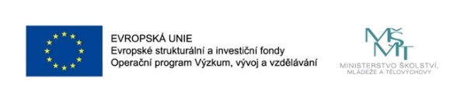

Communist Europe and the Caribbean during the Cold War: Diplomacy, Espionage, Migrations and Other Forms of Mutual
Engagement.

(International workshop)
September 25, 2019
Sweerts-Špork Palace, Hybernská 3, Prague 1, room no. 303
10.00 Opening of the Workshop
10.10 Darina Zavadilová (Academy of Arts, Architecture and Design in Prague, UMPRUM): Czechoslovak-Cuban cultural relations in the 1960s
10.40 Mónika Szente-Varga (National University of Public Service, Budapest): Sport Relations between Hungary and Cuba in the Cold War
11.10 Karolina Baraniak (University of Wrocław): The bilateral relations between the Polish People’s Republic and Cuba during the Cold War– case study
11.40 Kateřina Březinová (Metropolitan University, Prague): The Cultural Cold War in Latin America - The House of the Czechoslovak Culture in Cuba
12.10 Mervyn J.Bain (University of Aberdeen): Havana-Moscow Relations, the Nexus of Cold War Tensions

12.40 – 14.00 Lunch Break

14.00 Adelaida López (Occidental College, Los Angeles): Gabriel García Márquez in Prague

14.30 Radek Buben (Charles University, Prague): Czechoslovakia and Sandinist Nicaragua in the 1980’s.
15.00 Michelle D. Getchell (US Naval War College): Internationalizing the 1965 Dominican Crisis: The Soviet Bloc and the Politics of Regional Security in Latin America

15.30 Lukáš Perutka (Charles University, Prague): Informal diplomacy between Czechoslovakia and Guatemala and the fall of Jacobo Arbenz in 1954

16.00 Karol Derwich (Jagiellonian University, Kraków): The Cold War geopolitics of the Caribbean region

16.30-18.00 Roundtable Discussion

