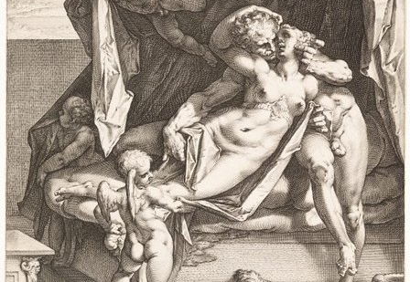
Hendrick Goltzius (1558–1617) after Bartholomaeus Spranger (1546–1611), Mars and Venus
Roma aeterna MMXVIII
The Afterlife of Ovid
in the Culture
of Central Europe
Prague, Vila Lanna
November 9 – 10, 2018
The workshop is held under the auspices of the projects KREAS and UNCE.
Programme
November 9, 2018
13:00 … Registration and Welcome Coffee
14:00 … Welcome Talk by Martin Bažil
Session I:
The Reception of Ovid from Late Antiquity to the Renaissance
Chairperson: Martin Bažil (Prague, Univerzita Karlova / Charles University)
14:20 … Marie Okáčová (Brno, Masarykova univerzita / Masaryk University):
Distant mores a carmine nostri: The Apologetic Use of a Catalogue of Literary Predecessors in Ovid and Ausonius
15:00 … Adam Jegorow (Kraków, Uniwersytet Jagielloński w Krakowie / Jagiellonian University in Kraków):
Medieval Pseudo-Ovidiana in the Collection of the Jagiellonian Library
15:40 … Monika Miazek-Męczyńska (Poznań, Uniwersytet im. Adama Mickiewicza w Poznaniu / Adam Mickiewicz University in Poznań):
The Polish Ovid from Januszkowo – Clemens Ianicius and His Tristia
16:20 … Afternoon Coffee
Session II:
Latin Literature and Theatre of the 16th and 17th Centuries
Chairperson: Magdaléna Jacková (Prague, Akademie věd České republiky / Czech Academy of Sciences)
16:40 … Marta Vaculínová (Prague, Akademie věd České republiky / Czech Academy of Sciences):
Descriptio monstri. Ovid-Rezeption im handschriftlichen Gedicht von Georg Bartholdus Pontanus (1550–1614)
17:20 … Eszter Kovács (Budapest, Országos Széchényi Könyvtár / National Széchényi Library):
Ovid’s Poems in the Printed Books of Sixteenth- and Seventeenth-Century Hungary
18:00 … Kateřina Bobková Valentová (Prague, Akademie věd České republiky / Czech Academy of Sciences) – Martin Bažil (Prague, Univerzita Karlova / Charles University):
Zwei dramatische Atalantae aus der böhmischen Jesuitenprovinz (2. Hälfte des 17. Jahrhunderts)
18:45 … Dinner
Theatre
19:45 … Arnoldus Engel S.J.: Atalanta et Hippomenes – an interlude of the play Costis sive Catharis Partheno-Martyr Alexandrina
Lauriger Theatre Company
November 10, 2018
Session III:
Literature of the 19th and 20th Centuries
Chairperson: Marie Okáčová (Brno, Masarykova univerzita / Masaryk University)
9:00 … Donato Gagliastro (Prague, Univerzita Karlova / Charles University):
The Young Ovid and the Young d’Annunzio: The Discovery of Female Readers
9:40 … Anikó Polgár (Bratislava, Univerzita Komenského v Bratislave / Comenius University in Bratislava):
Gábor Devecseri und die ungarische Ovid-Rezeption
10:20 … Maria Bartal (Budapest, Eötvös Loránd Tudományegyetem / Eötvös Loránd University):
The Poetics of Transformation. Ovid’s Metamorphoses as Thematic Inspiration, Model of Mythologization and Poetic Model in the Poetry of Sándor Weöres
11:00 … Morning Coffee
Session IV:
Imagines Ovidianae
Chairperson: Lenka Panušková (Prague, Akademie věd České republiky / Czech Academy of Sciences)
11:20 … Barbara Hodásová (Bratislava, Slovenská akadémia vied / Slovak Academy of Sciences):
Friendship Books of Ulrich Reutter and the Understanding of Ovid around 1600
12:00 … Radka Nokkala Miltová (Brno, Masarykova univerzita / Masaryk University):
Reception of Illustrated Prints of Ovid’s Metamorphoses in Bohemian and Moravian Art: Johann Jacob von Sandrart and the ‘Judgement of Tiresias’
12:40 … Markéta Kučerová (Prague, Akademie věd České republiky / Czech Academy of Sciences):
A Database of Literary Illustrations of Ovid’s Metamorphoses from the 16th to the 18th Centuries
13:20 … Closing Talk by Martin Bažil
13:45 … Lunch
The workshop is organized with the support of the following institutions and projects:
 |  | 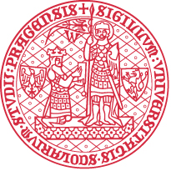 | 