PLATFORM CEFRES and TEMA ERASMUS MASTER INVITE YOU SINCERELY TO ATTEND

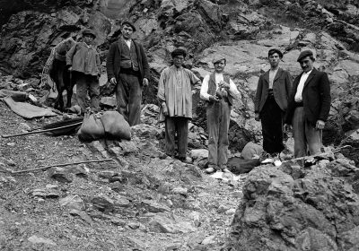

Workshop
Around the migrations in the 20th century - prospects from the two sides of the Channel.

Autour des migrations du 20e siècle – perspectives de deux côtés de La Manche
WITH
LAURE TEULIÈRES (TOULOUSE) AND SIMON GUNN (LEICESTER)

When: 27.4. 2017 (Thursday), 14:00-18:00
Where: Hybernská 3, Praha 1 (room 303)
Language – English, French in the discussion

PROGRAMME

Invited speakers:
Laure Teulières, professor of history, FRAMESPA (UMR CNRS 5136), Université Toulouse Jean-Jaurès : Representations of the foreigner in France after the First World War
Simon Gunn, professor of history, Centre for Urban History, University of Leicester: From Workers to Communities: Migration and the Politics of Ethnicity in Bradford, England, c.1945-1980

Comparative perspective from Central Europe:
Tereza Horáčková, PhD. Student under double supervision at the Faculty of Arts CU and EHESS: Diversity of a diaspora integrated through economic strategies: Vietnamese in the Czech Republic since the 1950s.

Nóra Abdel-Salám, MA student of TEMA Erasmus+ Master at the Faculty of Arts CU and EHESS : Diverging Migration Tendencies of the Youth in Central Europe - Case Studies of Hungary and the Czech Republic.

