Institute of South and Central Asia
Cordially invites you to attend talks by

CHARLES RAMBLE
Director of Studies (Director d’études) at the Ecole Pratique des Hautes Etudes, Paris
Member of CRCAO (Centre for Research on East Asian Civilisations), Paris
Lecturer at the Oriental Institute, Oxford University

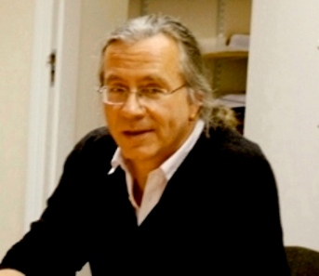

1. Understanding Himalayan Buddhist Communities through the Prism of Civil Religion.
Friday, November 13, Celetná 20, room No. 427, 2:10 pm

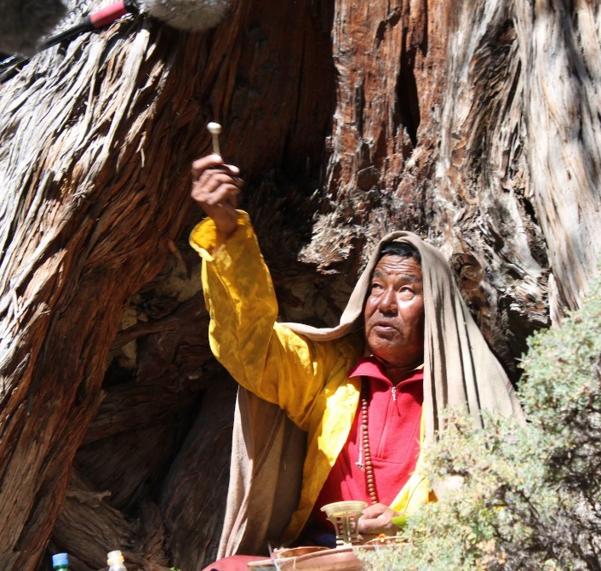

The idea of a confrontation of worldviews between Buddhist and non-Buddhist traditions features in several ethnographies of culturally Tibetan communities. Such a simplification of religious pluralism to one-to-one opposition is not necessarily the result of the anthropologist’s application of prefabricated categories; one has only to turn to the biographies of missionary lamas in the Himalayas, or Tibetan accounts of the introduction of Buddhism in the imperial period to see that here, too, the situation is represented in terms of religious polarisation. An ethno-historical case study from Nepal’s Mustang district suggests that the situation may be far more complex than a straightforward clash of two opposed worldviews: Buddhism and the local sacrificial cults are peripheral to a “dark” third manifestation of religion, which is produced by the complex interaction of individuals with their legal and political institutions. This complex is best understood in terms of civil religion, a concept developed by Rousseau and later elaborated by writers such as Robert Bellah and Gerald Parsons. While this reified community is ultimately the product of the individuals of which it is composed, it is perceived and represented as an autonomous, “transcendent” entity with a reciprocal influence on their lives.

2. Towards a Holistic Representation of Tibetan Ritual: Three Case Studies from a Himalayan Bonpo Community

Monday, November 16, Celetná 20, room No. 427, 5:30 pm

Attending a Tibetan ritual can be a confusing experience. Behind the noise, the chaotic activity and the seemingly interminable chanting it is often far from clear what is going on. While Tibetan ritual has attracted the attention of a number of very able researchers, their focus has, understandably, been on textual analysis. To the extent that analysis entails – literally – the “breaking up” of a complex entity, focusing on one aspect of ritual to the exclusion of the others is clearly not an ideal approach to the subject. In many cases, of course, the text is the only thing that is available to us, but when we are dealing with a living tradition, there is no reason to make a virtue out of a necessity, and innovative approaches may enable us to do justice to the multi-stranded nature of a ritual. This presentation will introduce three little-studied Bonpo rituals: Soul-retrieval (bla-’gugs), the “Three-Headed Man of the Black Rites” (gTo nag mgo gsum) and Vampire-crushing (Sri mnan), and will suggest how innovative methods of presentation might make it possible to convey the complexity of a given ritual performance while enabling a close study of its textual and performative aspects.

