OPEN CALL FOR DOCUMENTARY FILMS
CULTURE as RESISTANCE
in the Former Socialist Countries of Eastern Europe
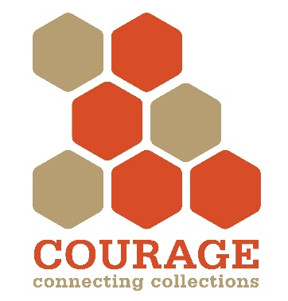
Together with PAREVO, the COURAGE Doc Fest is Eastern Europe’s first international competitive documentary film festival dedicated to cultural opposition and dissent in the former socialist countries. We are seeking high quality documentaries that are compelling, thought-provoking, and of interest to broad audiences.
The International Film Festival will feature innovative documentaries from around Central and Eastern Europe that touch on the culture of dissent in the former socialist countries.
The Film Festival awards a Festival Prize worth 1,000 euros to the director(s) of the best film. The selection will be made by the international jury (Jury Prize Winner). The prize will be awarded by the Danube Region Foundation, which is one of the oldest and biggest documentary producers and distributors in Hungary.
The films, which will be selected for inclusion in the festival by an international jury, will be screened in four major European cities between May and December 2018: Budapest, Bucharest, Prague, and Warsaw (as well as some other cities in the UK and in Germany as a traveling film festival).
The Festival invites submissions that are relevant to the general theme, but in particular with a focus on the following topics:
- The world of non-conformist art under socialism;
- Youth subcultures, underground music (rockers, hippies, punks);
- Experimental theatre;
- Alternative film, performance, and dance;
- Unofficial education and publishing activities (samizdat, flying universities);
- Human rights and ecological (green) movements;
- Traditionalist cultural groups (e.g. dance house movements);
- Émigré and dissident groups;
- Alternative lifestyle movements;
- New and clandestine religious communities.

Our mission is to discover and promote independent Eastern European documentaries and to showcase the best of these documentaries to international audiences. The COURAGE–PAREVO Documentary Film Festival will feature the most innovative and engaging documentaries from around Eastern Europe, from short documentaries to feature length, award-winning films. The COURAGE–PAREVO Documentary Film Festival provides a public forum and supportive platform to allow emerging filmmakers to showcase their work.

DEADLINES
FIRST ROUND: SUBMISSION OF ABSTRACTS by midnight September 29, 2017
Please send your abstracts to courage.filmfestival@btk.mta.hu
Candidates are requested to submit the following to apply:
- an abstract in English consisting of a written summary of the film, its aims, and its conclusions;
- contact details: email address(es) of the filmmaker(s);
- the length, date of production, and format of the film;
- a list of the names of the filmmaker(s) and the key actor(s)/interviewee(s);
- a declaration of rights clarifying the rights of the candidate to screen the film.

Preferably, films should be submitted with English subtitles, but we will provide English subtitling for selected films. Successful applicants will be contacted with details concerning uploading and posting by midnight October 16, 2017.
SECOND ROUND: SUBMISSION OF FILMS (upload) by midnight October 31, 2017.
Films are to be uploaded to a dedicated server OR are to be sent on DVDs in HD format – preferably with English subtitles – by midnight October 31, 2017. The filmmakers of documentaries selected for screening will be contacted by midnight November 30, 2017.
***
For more information on the international COURAGE project and PAREVO see:
cultural-opposition.eu
parevo.eu
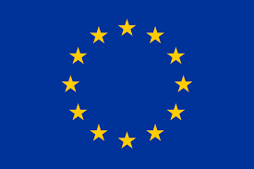

FILM ABSTRACT SUBMISSION FORM
Please send your abstracts to courage.filmfestival@btk.mta.hu by midnight September 29, 2017

TITLE OF THE FILM (in English):
TITILE OF THE FILM (in the original language):
NAME(s) of the filmmaker(s):
ABSTRACT of the film (max. 500 words):

YEAR of production:
Format:
Duration (minutes):
Languages:
Subtitles:
NAMES OF KEY ACTOR(S)/INTERVIEWEE(S) in the film:
CONTACT DETAILS: Name of Contact Person:
email address:
phone:

A declaration of rights clarifying the rights of the candidate to screen the film:
The undersigned filmmaker hereby declares that this film needs no additional license to be screened at the COURAGE–PAREVO international documentary film festival in 2018. This consent constitutes a legally binding affirmation that the COURAGE–PAREVO international documentary film festival has the filmmaker’s permission to screen the film in 2018 (public screening).

PLACE, DATE SIGNATURE
(name)

