25 MAY 2016, PRAGUE
PRESS RELEASE
Classical Enchantments at the Duchcov Chateau
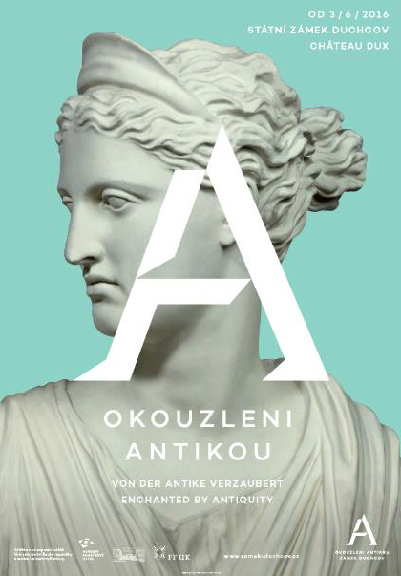
On Friday 3 June 2016, a new exhibition Enchanted by Antiquity opens at the Duchcov chateau. In eight chambers, almost 150 historical casts of famous and lesser-known pieces of classical art shall be exhibited. The new tour focuses on stories from classical mythology, classical culture, and the influence of the Antiquity on the lives of the aristocracy. Visitors can explore this new tour without a guide.
The new permanent exhibition at the Duchcov chateau introduces the classical legacy in European art from the Renaissance up to the present. It focuses on aristocratic “grand tours”, discoveries of classical monuments, the phenomenon of collecting classical art works, and the influence of the Antiquity on architecture and design of aristocratic residences. The exhibition also mentions classical influences in European theatre and visitors can admire reconstructions of baroque theatre costumes and stage props. Other items on display include several original pieces of funeral ceramics, historical travel equipment, travel souvenirs, and period paintings documenting how the aristocrats discovered the Antiquity.
The sculptures belong to the precious Collection of Classical Art Casts of the Faculty of Arts, Charles University. The most impressive items include the decorations of the gable from the Athena Aphaia temple in Aegina with ten nearly life-size figures. One of them, the so-called Paris, has been re-painted in order to recreate the original visual impact of classical art. The exposition presents one of the unique reconstructions made by Prof. W. Klein during his tenure at Charles University – Myron’s Athena and Marsyas.
The exhibition was prepared by the National Heritage Institute and the Faculty of Arts CU.
Authors: PhDr. Marian Hochel, Ph.D., PhDr. Olga Klapetková, PhDr. Eva Lukášová, doc. PhDr. Peter Pavúk, Ph.D., Mgr. Lenka Vacinová. Project Manager: Ing. Filip Malý.
Contact
Jana Hessová, +420 775 437 294; hessova.jana@npu.cz; www.npu.cz/cs/ups-praha
Marian Hochel, +420 777 478 256, duchcov@npu.cz, www.zamek-duchcov.cz
Ina Píšová, +420 777 739 951, ina.pisova@ff.cuni.cz, www.ff.cuni.cz/home

